Category: Easy

Competition: CSI KJSCE Code Wars 2017-18

Try it:

<https://www.hackerrank.com/contests/codewars2-round1/challenges/kjsce-design-team>

Question:

The designer team of KJSCE was making beautiful decorative patterns. Which looks as shown:

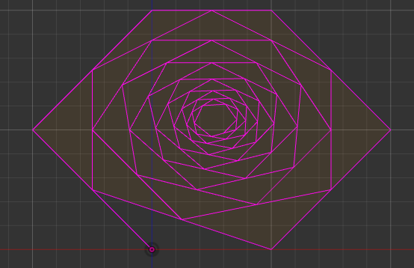

First 5 edges are previously mentioned ones

Each pattern is formed by considering e initial edges whose vertices will be given. (e + 1 )th edge is generated by joining end of eth edge with the **midpoint** of 1st edge, ( e + 2 )th is generated by joining midpoints of first and second edge and so on. The figure spirals into the region predefined by initial edges.

In the above figure, first 5 edges were provided initially. Rest of the edges were formed according to the above spiral logic.

The team wants to know the length of material needed for generating n-edged pattern inclusive of e edges taken in the beginning. Write a program to perform the above task.

Given:

n>=e.

Inputs:

2 <= number of initially given edges <=1000

x and y coordinates are real numbers between -1000 and 1000.

n: Integer less than or equal to 10^9

Output:

Length of the pattern. Round down the figure.

Eg. :

|  |  |
| --- | --- |
| **Input** | **Output** |
| 2 (number of edges being provided initially)  0 0 (x and y coordinates)  200 200  400 0  4 (total number of edges) | 1081 |

Try these inputs:

|  |  |
| --- | --- |
| **Input** | **Output** |
| 2  0 0  200 200  400 0  100 | 1442 |
| 3  0 0  -100 0  -100 100  0 100  50 | 1050 |
| 3  0 0  0 0  0 0  0 0  30 | 0 |
| 5  0 0  -0.2  0.2  0 0.4  0.2 0.4  0.4 0.2  0.2 0  50 | 7 |
| 4  0 0  1 20  10 30  20 35  30 30  15 | 206 |
| 4  0 0  1 20  10 30  20 35  30 30  4 | 55 |

|  |  |
| --- | --- |
| Was the above problem too easy??? Try these cases….  Think of a method to get their answer right and probably before the end of you memory or the universe ;) | |
| 2  0 0  200 200  400 0  1000000000 | 1442 |
| 5  0 0  -0.2  0.2  0 0.4  0.2 0.4  0.4 0.2  0.2 0  100000000 | 9 |
| 3  0 0  0 0  0 0  0 0  300000000 | 0 |
| 3  0 0  -100 0  -100 100  0 100  1000000 | 1052 |